PFR SPTS No. [SPTS]

Irrigating peas for optimal yields

Hamish Brown, Travis Ryan-Salter, Richard Gillespie, Nick Pyke, Mike George, Shane Maley, Alex Michel, Lincoln

[Month Year]

|  |
| --- |
| Confidential report for: |

[Client]

[Ref]



**-- Non-Printing text!! -- INSTRUCTIONS FOR USING THIS TEMPLATE:   
Fill in** all **RED** FIELDS **only** then open File–PRINT [to Preview] then back-arrow out – to force **[grey]** fields to auto-update throughout the document. **Repeat** this process if you update any red fields later and want to update again.  
See **HOME** ribbon, Style box where there are 2 rows to scroll for heading options.  
IF you opened this template using File–Open instead of double-clicking the icon to open, use “SAVE AS” and make sure file extn is “.docx”.

Press Alt+Crtl+Shift+S to open the styles gallery – turn on the Show Preview options to see all the styles available for use in this template. Click our link: [RATT](https://iplant.plantandfood.co.nz/Publishing/Documents/RATT_Report%20And%20Template%20Tips.docx?Web=1) for more Tips!

DISCLAIMER

The New Zealand Institute for Plant and Food Research Limited does not give any prediction, warranty or assurance in relation to the accuracy of or fitness for any particular use or application of, any information or scientific or other result contained in this report. Neither The New Zealand Institute for Plant and Food Research Limited nor any of its employees, students, contractors, subcontractors or agents shall be liable for any cost (including legal costs), claim, liability, loss, damage, injury or the like, which may be suffered or incurred as a direct or indirect result of the reliance by any person on any information contained in this report.

LIMITED PROTECTION

This report may be reproduced in full, but not in part, without the prior written permission of The New Zealand Institute for Plant and Food Research Limited. To request permission to reproduce the report in part, write to: The Science Publication Office, The New Zealand Institute for Plant and Food Research Limited – Postal Address: Private Bag 92169, Victoria Street West, Auckland 1142, New Zealand; Email: SPO-Team@plantandfood.co.nz.

CONFIDENTIALITY

This report contains valuable information in relation to the [Programme] programme that is confidential to the business of The New Zealand Institute for Plant and Food Research Limited and [Client]. This report is provided solely for the purpose of advising on the progress of the [Programme] programme, and the information it contains should be treated as “Confidential Information” in accordance with The New Zealand Institute for Plant and Food Research Limited’s Agreement with [Client].

COPYRIGHT

© COPYRIGHT (2022) The New Zealand Institute for Plant and Food Research Limited. All Rights Reserved. No part of this report may be reproduced, stored in a retrieval system, transmitted, reported, or copied in any form or by any means electronic, mechanical or otherwise, without the prior written permission of the of The New Zealand Institute for Plant and Food Research Limited. Information contained in this report is confidential and is not to be disclosed in any form to any party without the prior approval in writing of The New Zealand Institute for Plant and Food Research Limited. To request permission, write to: The Science Publication Office, The New Zealand Institute for Plant and Food Research Limited – Postal Address: Private Bag 92169, Victoria Street West, Auckland 1142, New Zealand; Email: SPO-Team@plantandfood.co.nz.

PUBLICATION DATA

[Authors]. [Month Year]. [Enter Title Here]. A Plant & Food Research report prepared for: [Client]. Milestone No. [Milestone#]. Contract No. [Contract#]. Job code: [Job Code]. PFR SPTS No. [SPTS].

**Report prepared by:**

[Enter Lead Author Here]

Scientist/Researcher, [Enter Team Here]  
[Month Year]

**Report approved by:**

[Enter SGL Name Here]  
Science Group Leader, [Enter Group Here]  
[Month Year]

Contents

Executive summary 1

1 Introduction 2

2 Methods 2

2.1 Rain shelter experiment 2

2.1.1 Site and crop 2

2.1.2 Irrigation 3

2.2 Measurement 3

2.2.1 Crop yield and components 3

2.2.2 Canopy cover. 3

2.2.3 Soil Water 4

2.2.4 Surface temperature and meteorological measurements 4

3 Pea crop responses to irrigation 5

3.1 Crop production, yield components and health 5

3.2 Rain shelter canopy covers 7

3.3 Rain shelter soil water deficits 8

3.4 Rain shelter water extraction patterns 9

4 Estimating crop water use using IR temperature 12

Executive summary

|  |
| --- |
| [Enter Title Here]  [Authors] Plant & Food Research: 1[Location], 2[Location]  [Month Year] |

For further information please contact:

[Enter Lead Author Here]

[Choose an office location]

Email: [Email]

# Introduction

Peas are a shallow rooted crop with a low tolerance to root anoxia (water logging). They are therefore sensitive to both water shortage and excess so require careful irrigation management to achieve reliable high yields.

In addition, peas require good pollination to achieve high seed numbers and yield potentials. There is a belief that wetting the canopy (and flowers there in) during flowering hinders pollination and reduces grain number and yield. However there is little experimental evidence to support his

The aims of this work were:

* To determine the response of pea yields to different timings and frequencies of drip and sprinkler irrigation.
* To assess the ability an infra-red radiometer based technique to measure pea water use and determine optimal irrigation requirements.

# Methods

## Rain shelter experiment

### Site and crop

The experiment was conducted in the Plant and Food Research rain shelter near Lincoln. The facility has been described in detail by Martin et al. (1990). Briefly, it is a 15 x 50 m glass house mounded on rollers and attached to a winch that allow it to travel up and down a pair of long rails. The rails are 200 m long giving 4 separate stopping positions for the shelter so areas can be planted in restorative grass to maintain soil quality between experimental crops. The control systems pulls the shelter over the experimental area when-ever rain is detected (by moisture sensors on the winch shed) and rolls it back off once when the rain has stopped. The soil is a Templeton silt loam with 160 mm of available water per mm depth.

The area was in mown grass for the 3 years prior and was ploughed on the the 7th of September, power harrowed on the 18th of October. Fertiliser (Cropzeal 16N, 150kg/ha) and herbicide (Trifluralin, 1.7 l/ha) were applied on the 21st of October and cultivated twice to incorporate. A crop of Canterbury 37 peas were sown in 11.8 cm rows with an Amazone crop drill targeting a population of 114 plant/m2 on the 28th of October. Pre emergent herbicide (Magister @ 250ml/ha and Magneto @ 2L/ha with 300L water/ha) was applied the day following sowing.

During crop growth herbicide (Pulsar @ 5 l/ha) was applied on the 26th of November and fungicide (Amistar @ 300ml/ha and Proline @ 400ml/ha) and insecticide (Karate @ 30ml/ha with 300L water/ha) were applied on the 14th of December.

### Irrigation

The rain-shelter was position away from the experiment following establishment until the 20th of November. During this time 14.6mm of rain. In addition, all plots were irrigated in common on the 5th and 8th of November (to ensure even establishment) with hand shift sprinklers applying 10mm each time.

Following establishment Irrigation was applied to each plot through an array of dripline with emitters spaced XX cm apart and lines spaced XX cm apart. Arrays on each plot were operated independently. Control of the amount and timing of irrigation to each plot was … Trav please provide some info about the control system

The experiment had 24 plots which consisted of 4 replicates of 6 different irrigation treatments

* 2D – irrigation applied every 2nd day to replace estimated ET
* 7D – irrigation applied every 7th day to replace estimated ET
* 14D – irrigation applied every 14th day to replace estimated ET
* 21D – irrigation applied every 21st day to replace estimated ET
* MD – No irrigation prior to flowering then irrigation as for 7D
* LD – Irrigation as for 7D until flowering then no irrigation

For the 2D, 7D, 14D and 21D treatments, ET was estimated using an approach described by Brown, *et al.* (2021). In short, surface temperature was measured on each plot at 5 min intervals using Apogee infra-red radiometers (IRR) and green crop cover was measured using NDVI. This data was combined with local meteorological data (Temperature, humidity and solar radiation) to give an estimate of daily water use that accounts for climate effects on potential ET and incomplete canopy and water shortage on actual ET. Estimated ET was accumulated between irrigations and the amount of ET calculate is what was applied to each treatment.

## Measurement

### Crop yield and components

Trav, can you put some details in here on crop measurement

### Canopy cover.

Linear radiation sensors (30 cm length, Solems) were installed below each crop to monitor radiation interception by the canopy. In addition NDVI was measured from flowering onwards to quantify the reduction in green cover of the canopy. NDVI measurements were converted to green cover as described by (Brown, Jamieson, Hedley, *et al.* 2021).

### Soil Water

Water content reflectometers (Campbell Scientific CS650) were installed in each plot at each of the following depths: 0-15 cm (two sensors per plot, one within drill rows and one between drill rows); 15-30 cm; 30-60 cm; 60-90 cm; 90-120 cm; 120-150 cm; 150-180 cm. Each sensor was connected to a data logger and soil moisture recorded at 15 min intervals throughout the duration of the experiment. Full details of the installation and operation of these sensors is given by Brown, Jamieson, Michel, *et al.* (2021).

### Surface temperature and meteorological measurements

The same equipment and procedure was used in this experiment as described by Brown, *et al.* (2021). Briefly, Apogee IRR sensors were installed in each plot and maintained at ~1m above the crop canopy. A meteorological station was established beside the rain-shelter and a national meteorological station is situated ~300 m away which provided back up.

# Pea crop responses to irrigation

## Crop production, yield components and health

Crop data from the rain-shelter and field experiment were combined for analysis (Figure 1). For each variable measured an anova was conducted to compare the 6 treatments in the rainshelter. The 7D and MD treatments were duplicated in the field (under full rainfall and overhead sprinkler irrigation) and these were compared to the corresponding treatment in the rainshelter with a t-test.

There were no treatment differences in plant population with a mean of 110 plant/m2(Figure 1). There were significant yield differences between irrigation treatments in the rain-shelter with the 2D and the 7D treatments achieving the highest (4.9-5.3 t/ha) yields and the 21D, LD and MD treatments achieving the lowest (3.5-3.7t/ha) yields (Figure 1). 160 mm of rain fell between 20 November (when rainshelter was activated) and 20 January (when the crop was harvested) and only small amounts of irrigation were applied in the field so there were no treatment differences. The MD treatment in the field yield more than the equivalent treatment in the rain-shelter because it received plenty of rainfall when the mid drought treatment was to be applied. There was no difference between the 7D treatment in the field and the rainshelter suggesting avoidance of canopy wetness during flowering did not impact pollination and yield potential. However, there was a significant reduction in yields for crops that received water stress during flowering (MD treatment) suggesting it is more important to manage irrigation to avoid water deficit than it is to try to achieve a dry canopy during flowering.

The number of reproductive nodes per plant, number of pods per reproductive node and number of seeds per plant all followed the same pattern as crop yield with highest values for the 2D and 7D treatments and lowest values for the 21D and MD treatments (Figure 1). Correlation plots of yield components are presented in Figure 2 with bounds shown by the lines represent maximum and minimum slopes. Differences between values on the y variable could be due to a change in the x variable with a constant slope or a change in slope with no change in the x variable. Thus, treatments may differ in the value they have on the y-axis by moving up or down the line that marks the mean slope or they may have a different slope and move away from the mean. Considering first the population graph (Figure 2), no treatments showed clear deviations from the mean, which means the all the variation in yield was coming from changes in yield per plant rather than changes in plant number. The LD treatment showed clear deviation from the mean and to a lesser extent, the MD treatment (Figure 2) meaning part of their yield reduction could be attributed to reduced seed size. There were strong correlations for seed set and pod set with no clear deviations from the mean showing that variations in yield from seed number reduction were related to reductions in the number of flowering nodes rather that a reduction in the number of pods per node or seeds per pod. This suggests that the drought treatments were causing a reduction in the number of flowers being pollinated rather than the effectiveness of pollination for individual flowers.

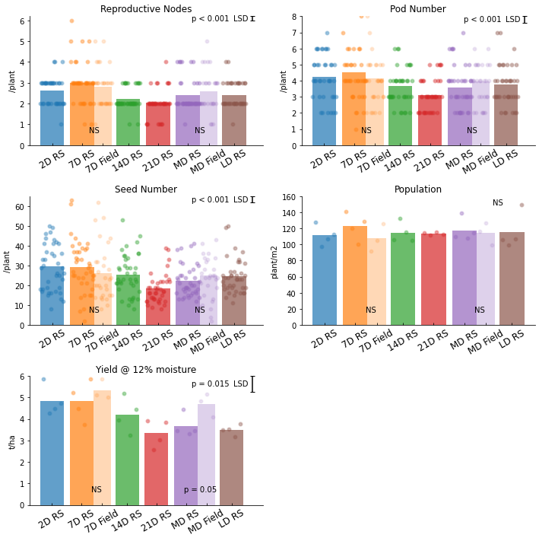

Figure 1. Reproductive node numbers, pod numbers, seed numbers, population and yield, for `Canterbury 37` peas grown in the Plant and Food Research rain shelter near Lincoln with 6 different irrigation treatments and for two sprinkler irrigation treatments in the adjacent field. Individual data points are shown by round symbols and bars represent the mean for each treatment. Different colours represent different irrigation treatments. The paired bars represent the same irrigation treatment with the darker bar being drip irrigated under the rainshelter and the lighter bar being sprinkler irrigated in the field. The probabilities on top of these paired bars are from a t test comparison of the two. Probabilities and LSD in the top corner of each graph is from an ANOVA for the rainshelter treatments.

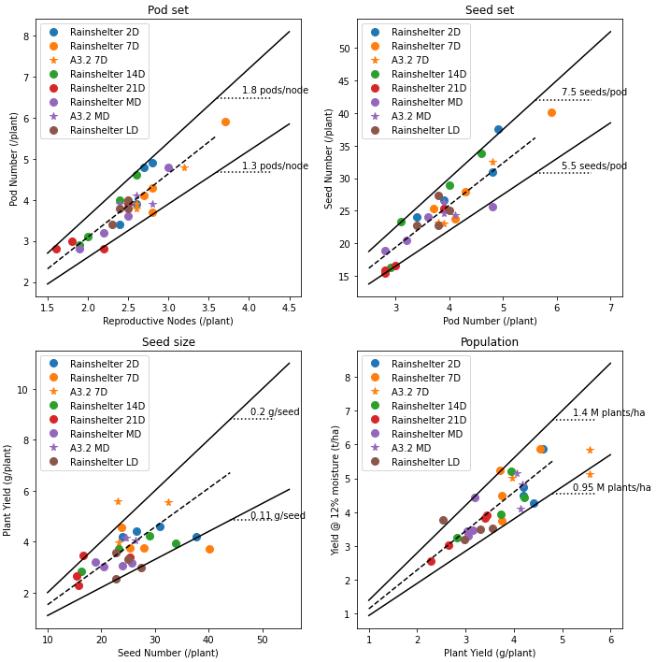

Figure 2. Yield component correlation graphs for `Canterbury 37` peas grown in the Plant and Food Research rain shelter near Lincoln with 6 different irrigation treatments and for two sprinkler irrigation treatments in the adjacent field (A3.2). Dashed lines represent the mean slope of the y and x variables (y/x) and solid lines represent the upper and lower bounds.

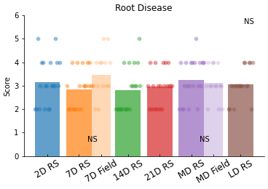

Figure 3. Root disease scores for `Canterbury 37` peas grown in the Plant and Food Research rain shelter near Lincoln with 6 different irrigation treatments and for two sprinkler irrigation treatments in the adjacent field. Individual data points are shown by round symbols and bars represent the mean for each treatment. Different colours represent different irrigation treatments. The paired bars represent the same irrigation treatment with the darker bar being drip irrigated under the rainshelter and the lighter bar being sprinkler irrigated in the field. The probabilities on top of these paired bars are from a t test comparison of the two. Probabilities and LSD in the top corner of each graph is from an ANOVA for the rainshelter treatments.

## Rain shelter canopy covers

There were few visible differences early in the crops duration and all treatments achieved full canopy closure about mid December. Treatment differences became apparent in January with the 21D treatment loosing green cover in its canopy fastest. The MD, LD and 14D treatments all had a similar rate of canopy senescence (Figure 4). These are all treatments that encountered some degree of water stress during or prior to this time. The 7D and the 2D irrigation treatments gave the longest survival of green canopy. All treatments reached full canopy senescence (fPAR = 0) between the 18th and the 25th of January.

These results clearly show frequent irrigation throughout the season gave and extended crop duration. The MD and LD treatments senesced at the same rate in spite of the MD treatment receiving weekly irrigation during the senescence period. This shows moisture stress prior to the onset of canopy senescence can accelerate canopy decline later in the crop.

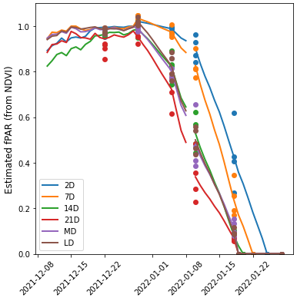

Figure 4. Estimated fPAR (faction of photosyntheticly active radiation) for `Canterbury 37` peas under 6 different irrigation treatments in the Plant and Food Research rain-shelter near Lincoln. Values prior to 28-12-21 were measured with continuously logged below canopy radiation sensors and beyond this date they were based on 5-7 day NDVI measurements (symbols) that were extrapolated out to daily values (lines).

## Rain shelter soil water deficits

Soil water deficit was calculated for each treatment assuming the soil was at field capacity on the day soil moisture commenced (Figure 5). Irrigation began on the 3rd of December for relevant treatments and proceeded until each treatments canopy was close to fully senesced (Figure 5). The 2D treatment maintained a SWD between 0 and 20 mm throughout the duration of the experiment. This is an important result because it shows that the amount of irrigation applied closely matched water use. Irrigation applications were calculated using a new approach based on IR canopy temperature and the ability of this approach to maintain soil water content in a tightly defined range is very encouraging.

The 7D, 14D and 21D treatments occupied a progressively wider range of soil water deficits, which is expected as they had longer to dry down between progressively larger irrigation amounts. There was little difference between the MD and the LD treatments prior in December because weather conditions were cool and dull and the crops did not use much water. The LD treatment reached the greatest SWD by the end of the experiment (-85 mm) with the MD, 21D and 14D treatments all reaching a SWD around - 60 mm by the end.

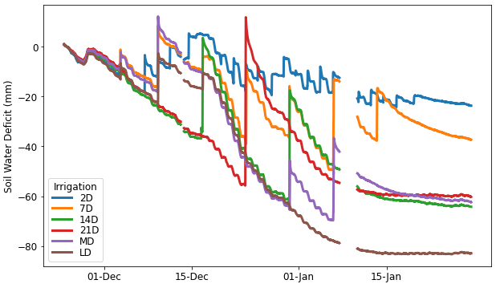

Figure 5. Soil water deficit for `Canterbury 37` peas grown in the Plant and Food Research rain shelter near Lincoln with 6 different irrigation treatments.

## Rain shelter water extraction patterns

Changes in volumetric water content at each depth are shown in Figure 6. The VWC fluctuated most in the top 15cm layer where irrigation was absorbed and crop water extraction was most significant. There appeared to be a difference between the VWC measured within the drill rows and that measured between drill rows for the 2D treatment with VWC being lower within the drill rows. Fluctuations due to irrigation and root uptake are evident in the 15-30 and 30-60 cm layers showing peas are actively extracting water at these depths. Wetting from irrigation events did not make it to the 60-90 cm layer and gradual water extraction is evident from this layer during the middle of December to mid January. Water extraction from this layer was least for the 2D treatment (which had the smallest SWD) and greatest for the LD treatment (which had the largest SWD).

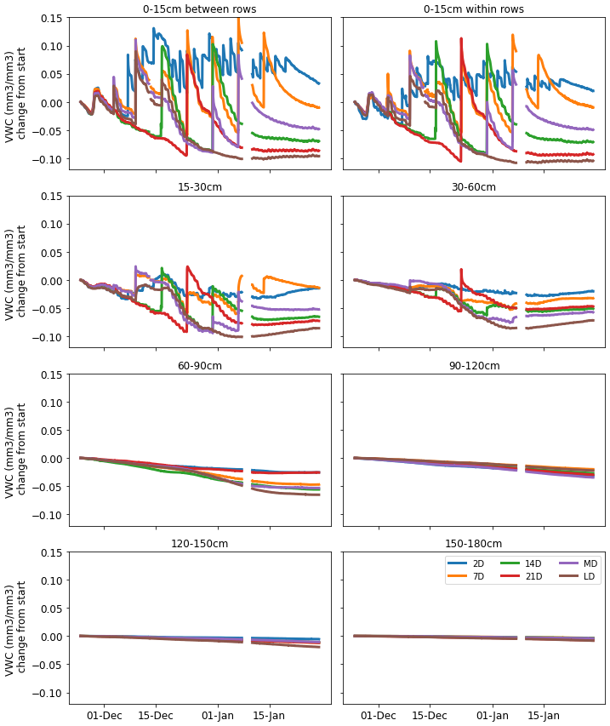

Figure 6. Change in water content (mm3/mm3) relative to starting value for soil layers down to 180cm for `Canterbury 37` peas grown in the Plant and Food Research rain shelter near Lincoln with 6 different irrigation treatments.

# Estimating crop water use using IR temperature

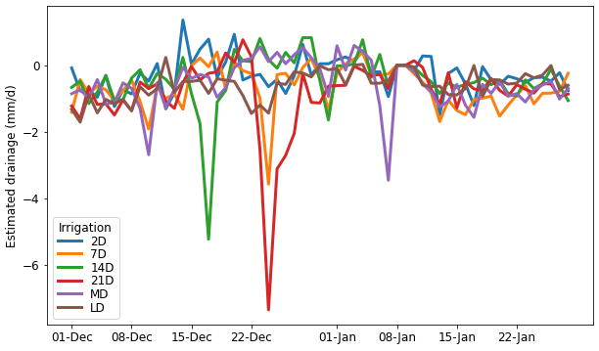

Figure 7 Drainage estimated from night time profile water fluxes for `Canterbury 37` peas grown in the Plant and Food Research rain shelter near Lincoln with 6 different irrigation treatments.

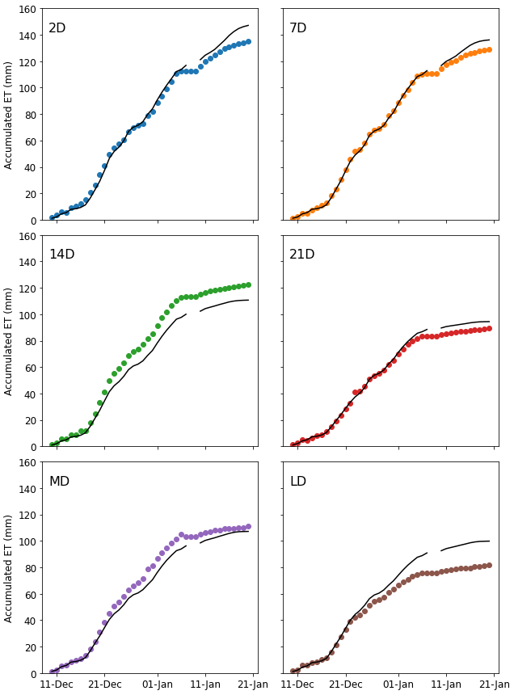

Figure 8. Accumulated evapotranspiration (ET) measured using soil moisture sensors (markers) and estimated using IR temperature data (lines) for `Canterbury 37` peas grown in the Plant and Food Research rain shelter near Lincoln with 6 different irrigation treatments